**System component logs**

There are two types of system components: those that run in a container and those that do not run in a container. For example:

* The Kubernetes scheduler and Kube-proxy run in a container.
* The kubelet and [container runtime](https://kubernetes.io/docs/setup/production-environment/container-runtimes) do not run in containers.

On Linux nodes that use systemd, the kubelet and container runtime write to journald by default. You use journalctl to read the systemd journal; for example: journalctl -u kubelet.

If systemd is not present, the kubelet and container runtime write to .log files in the /var/log directory. If you want to have logs written elsewhere, you can indirectly run the kubelet via a helper tool, kube-log-runner, and use that tool to redirect kubelet logs to a directory that you choose.

System components inside containers always write to .log files in the /var/log directory, bypassing the default logging mechanism.

**Node OS**:

Every node actually is running on a Linux box right and it has its own concept of logging, if you know anything about Linux there's a VAR/logs/ for our log okay so there's a bunch of logs here

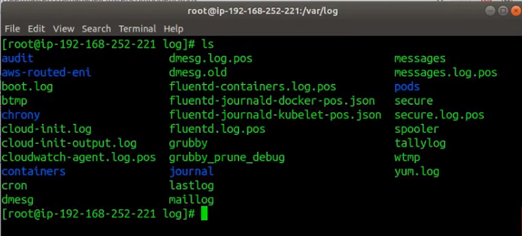

The most important are at least for the case of the OS is there's a messages, another one called secure which has to do with security stuff right like credentials and logins

OS log: /var/log/messages

OS security log: /var/log/secure

**Container Engine (Docker):**

Logs that a docker maintains itself, docker itself is a service that maintains its own logs and Docker runs as systemd process which means you can use a command called Journal right and you can watch those logs and this is the logs of Docker itself.

journalctl -u docker.service –f

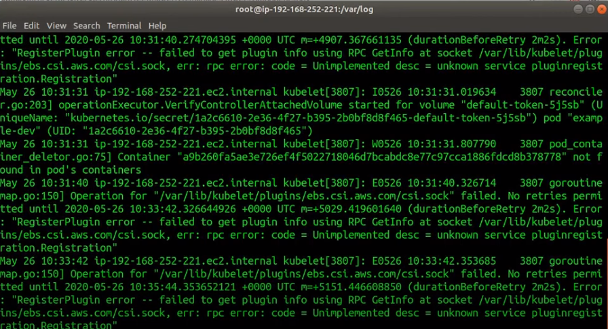

**Kublet:**

Similarly, like Container Engine (Docker) kubelet is running as a systemd process and you can also get at its logs too using command called Journal

journalctl -u kubelet.service –f

**kube-proxy (and other system Daemons):**

Kube-proxy run as container, while the K8s documents would suggest that the logging for Kube-proxy would by-pass the normal container logging approach.

As we checked on EKS node log should be present on “/var/log/kube-proxy.log” but there in no file called kube-proxy.log.

But there are container logs if you fire **kubectl logs kube-proxy-X** command

**Control Plane**

The K8s documentation suggest that the control plane logging (on the Master Node) is in the following locations:

/var/log/kube-apiserver.log

/var/log/kube-scheduler.log

/var/log/kube-controller-manager.log